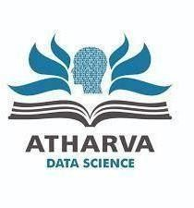

ATHARVA EDUCATIONAL TRUST’S

ATHARVA COLLEGE OF HOTEL MANAGEMENT & CATERING TECHNOLOGY
(Recognized by Government of Maharashtra & Affiliated to University of Mumbai- Estd. 2007-2008)
ISO 9001:2015 ISO 22000:2018
NAAC Accredited

DEPARTMENT OF DATASCIENCE

PROJECT REPORT ON:
ACADEMIC GUIDANCE AND INTELLIGENCE SYSTEM (AGMIS)

IN THE PROGRAM BACHELOR OF DATA SCIENCE
NAME: HAMZASIDDIQUI TY B. Sc. DATA SCIENCE ROLL NO.: 50
SEMESTER VI
UNDER THE GUIDANCE OF ASST. PROF. HARISH MAHALE ACADEMIC YEAR
2025-26



ATHARVA EDUCATIONAL TRUST’S

ATHARVA COLLEGE OF HOTEL MANAGEMENT & CATERING TECHNOLOGY
(Recognized by Government of Maharashtra & Affiliated to University of Mumbai- Estd. 2007-2008)
ISO 9001:2015 ISO 22000:2018
NAAC Accredited

CERTIFICATE

This is to certify that Mr.Hamza siddiqui of Third Year B.Sc. Data Science, Div.:B , Roll No. 50 of Semester VI (2025 - 2026) has Satisfactorily completed the documentation phase of the Project on the topic “ACADEMIC GUIDANCE AND INTELLIGENCE SYSTEM (AGMIS)” as per the guidelines of Atharva college of Hotel Management & Catering Technology, Charkop Naka, Malad West, Mumbai, Maharashtra 400095.

Asst. Prof. Harish Mahale
Teacher In-Charge

Dr. Preety Jain
External Examiner Principal

DECLARATION BY LEARNER

I, the undersigned, Mr.Hamza Siddiqui hereby declares that the work embodied in this project work titled ACADEMIC GUIDANCE AND INTELLIGENCE SYSTEM (AGMIS) forms my own contribution to the research work carried out under the guidance of Asst. Prof. Harish Mahale and is a result of my own research work.

This project, developed as part of our pursuit of a Bachelor of Science degree in Data Science, represents the culmination of our academic journey. It has not been duplicated or submitted elsewhere for any academic purpose.
We attest to the authenticity and uniqueness of our work, recognizing its significance within the field of data science and interactive multimedia platforms. With dedication and integrity, we have strived to meet the standards set forth by Atharva College of Hotel Management and Catering Technology and the broader academic community.

Guided by

Asst. Prof. Harish Mahale

ACKNOWLEDGEMENT

I express my sincere gratitude to all the individuals and institutions whose guidance, support,
and encouragement contributed to the successful completion of the
ACADEMIC GUIDANCE AND INTELLIGENCE SYSTEM (AGMIS) project.
This work is the result of continuous mentorship, teamwork, and institutional support.

I am deeply thankful to Asst. Prof. Harish Mahale for his valuable technical guidance and
consistent support throughout the development of this project. His insights and
direction played a crucial role in shaping the system architecture and implementation.

I would also like to thank our Course Coordinator, Asst. Prof. Aishwarya Shindde
, for her constant motivation, guidance, and encouragement during the project lifecycle.

My sincere appreciation goes to our Principal, Dr. Preety Jain, whose leadership, vision, and
unwavering support created an environment that promotes innovation and academic excellence.

I am grateful to the management of Atharva College of Hotel and Catering
Management Technology for providing the necessary infrastructure, facilities, and
resources that enabled the smooth execution of this work.
I extend my thanks to all faculty members and staff for their knowledge, cooperation,
and support, which laid a strong foundation for completing this project successfully.
Finally, I acknowledge the contributions of various technical communities and
support resources that assisted in the areas of software development,
artificial intelligence integration, and deployment.

ABSTRACT

The Academic Guidance and Intelligence System (AGMIS) is a data-driven platform that bridges the gap between academic data collection and actionable intervention in higher education. In the current Indian college setup, attendance, internal marks, assignment records, and examination scores are collected throughout the semester but used mainly for final evaluation. This leads to late identification of at-risk students, often in weeks twelve to sixteen, when effective intervention is difficult. AGMIS shifts this by enabling proactive identification of academic risk four to six weeks before critical evaluation points.

AGMIS has three main analytical parts: a classification engine, a prediction engine, and a guidance engine. The classification engine uses a Random Forest classifier to place students into five levels—Excellent, Good, Average, At Risk, and Critical—using a weighted mix of attendance percentage, internal marks, assignment completion rate, and examination scores. The prediction engine uses a Random Forest Regressor to forecast the next examination score (e.g. CEM-2 or semester-end) with a confidence interval, trained with a temporal sliding window so predictions use only data available at prediction time. The guidance engine uses rule-based logic to map performance patterns to concrete recommendations, with each message tied to a rule and an estimated impact on future performance

.The system is organised in a five-layer architecture: Presentation (Faculty and Student dashboards), Application (FastAPI backend), Analytics (classification, prediction, guidance), Data Processing (validation, feature engineering, history), and Data (PostgreSQL via Supabase). Role-based access gives faculty data upload, batch analytics, and risk alerts, and gives students read-only access to their performance, predictions, and guidance. The design favours explainability: predictions come with feature importance, and guidance messages are linked to specific rules.

The project applies data science to a real institutional setting, combining classification, regression, and rule-based systems within an ethical frame. It uses only institutional academic data, avoids behavioural surveillance, and acts as decision-support that supports rather than replaces faculty judgment. Success is measured by: classification accuracy > 75%, prediction MAE < 6 marks, and faculty being able to answer: “Which students need intervention this week, and why?”

Keywords: Academic Analytics, Early Warning System, Random Forest Classification, Regression Prediction, Rule-Based Guidance, Explainable AI, Educational Data Mining, Proactive Intervention

PERFORMA FOR THE APPROVAL PROJECT

Roll No.: 56

- Name of the Student:

Hamza Siddiqui

- Title of the Project:
The Academic Guidance and Intelligence System (AGMIS)

- Name of the Guide:

Asst. Prof.Harish Mahale

Signature of the Student Signature of the Guide 1
Date: ……………… Date: ………………

Signature of the Coordinator Date: ………

CONTENTS
Chapter | Title | Page
1 | INTRODUCTION
1.1 | Background
1.2 | Problem Statement
1.3 | Academic Context
1.4 | Motivation
1.5 | Objectives
1.6 | Scope
1.7 | Applicability
1.8 | Expected Impact
2 | LITERATURE SURVEY
3 | SYSTEM STUDY AND ANALYSIS
3.1 | Existing System
3.2 | Limitations of Existing System
3.3 | Proposed System
3.4 | Requirement Analysis
3.5 | Feasibility Study
3.6 | Stakeholder Analysis
4 | SYSTEM DESIGN
4.1 | Overall Architecture
4.2 | Layered Architecture
4.3 | Data Flow Diagrams
4.4 | Use Case Diagram
4.5 | Sequence Diagrams
4.6 | Deployment Diagram
4.7 | Component Diagram
4.8 | Database Design
4.9 | ER Diagram
4.10 | Schema Description
5 | ALGORITHMIC DESIGN
5.1 | Feature Engineering
5.2 | Classification Model
5.3 | Regression Prediction Model
5.4 | Guidance Rule Engine
5.5 | Statistical Analytics
5.6 | Explainability Strategy
5.7 | Model Comparison Justification
6 | IMPLEMENTATION
7 | RESULTS AND OUTPUTS
8 | TESTING AND VALIDATION
9 | DEPLOYMENT
10 | ETHICS, SECURITY AND PRIVACY
11 | LIMITATIONS
12 | FUTURE SCOPE
13 | CONCLUSION
 | REFERENCES
 | APPENDICES

LIST OF FIGURES:

Figure No. | Title | Page
4.1 | Overall System Architecture
4.2 | Five-Layer Architecture Diagram
4.3 | Data Flow Diagram Level 0
4.4 | Data Flow Diagram Level 1
4.5 | Use Case Diagram
4.6 | Sequence Diagram – Data Upload
4.7 | Sequence Diagram – Student Dashboard Load
4.8 | Deployment Diagram
4.9 | Component Diagram
4.10 | Entity-Relationship Diagram
5.1 | Feature Engineering Pipeline
5.2 | Classification Model Workflow
5.3 | Temporal Sliding Window for Prediction
6.1 | Faculty Dashboard Screenshot
6.2 | Student Dashboard Screenshot
7.1 | Performance Distribution Chart
7.2 | Academic Trajectory Chart
7.3 | At-Risk Student List
7.4 | Guidance Messages Display

LIST OF TABLES

Table No. | Title | Page
3.1 | Functional Requirements Summary
3.2 | Non-Functional Requirements Summary
4.1 | Access Control Matrix
4.2 | Database Schema – Core Tables
4.3 | Database Schema – Prediction Tables
4.4 | Database Schema – History and Audit Tables
5.1 | Classification Feature Description
5.2 | Prediction Feature Description
5.3 | Guidance Rule Examples
7.1 | Classification Accuracy Results
7.2 | Prediction Accuracy Metrics
8.1 | Test Cases

CHAPTER 1:

INTRODUCTION

Background
In today’s competitive job market, effective interview preparation is essential for students and job seekers. Traditional methods like coaching or peer practice are often expensive, generic, or lack personalization. Existing platforms such as Pramp and V Mock provide useful resources but do not offer real-time AI-driven analysis.
The AI-Powered Mock Interview addresses these gaps by using Artificial Intelligence, NLP, and speech analysis to simulate realistic interview scenarios. It provides personalized feedback, performance analytics, and interactive dashboards for progress tracking. The system is developed using Python, TensorFlow, Speech Recognition APIs, and modern web technologies like Flask/Django and ReactJS. It supports both Technical and HR interview rounds, helping users improve communication and problem-solving skills. This project is designed to be affordable, adaptive, and accessible to all. It serves as a valuable tool for students, job aspirants, and training institutes.

Purpose
The purpose of this project is to develop Ace: AI Mock Interview System, an intelligent platform that uses artificial intelligence to simulate real-life interview experiences. The system aims to help students and professionals prepare effectively for interviews by providing personalized feedback and performance analysis.
The system will aim to:
    - Automate interview practice by conducting AI-based mock interviews through voice or text interaction.
    - Improve communication skills by analyzing tone, clarity, and confidence in responses.
    - Enhance preparation by offering customized questions based on job roles, skills, or domains.
    - Provide real-time evaluation and detailed performance reports including strengths and areas for improvement.
    - Ensure accessibility and convenience by allowing users to practice anytime and

receive instant feedback.

  - Objectives

The objectives of the Ace: AI Mock Interview System are:

- To develop an AI-based platform that conducts realistic mock interviews using voice or text input.

- To analyze candidate responses using natural language processing (NLP) and machine learning techniques.
- To evaluate performance based on key interview parameters such as confidence, fluency, accuracy, and relevance of answers.

- To generate automated feedback reports highlighting strengths, weaknesses, and improvement suggestions.
- To create a user-friendly interface for easy access, smooth interaction, and personalized interview experiences.

- To assist students and job seekers in building confidence and improving their interview preparation effectively.
- To enhance learning outcomes by providing detailed analytics and performance tracking over multiple sessions.

Scope
The scope of the Ace: AI Mock Interview System covers the development of an intelligent, automated platform that simulates real interview scenarios for students and professionals. The system uses artificial intelligence and natural language processing to conduct, analyze, and evaluate interviews efficiently.
The scope includes:

    - AI-driven interview simulation that asks domain-specific and general questions based on user input or selected job roles.

    - Voice and text interaction to provide a realistic interview experience.
    - Automated evaluation of candidate performance, including content accuracy, communication skills, and confidence level.

    - Performance analytics dashboard to track progress and improvement over time.
    - Feedback generation with personalized suggestions for better preparation.
    - User authentication and data storage to maintain records of previous interview sessions.
    - Accessibility through a web-based or desktop application, ensuring easy use for

learners and job aspirants.

This project focuses on enhancing interview readiness through AI-based automation, making the process more efficient, interactive, and insightful.

Applicability

The Ace: AI Mock Interview System is applicable across various domains where interview preparation and performance assessment are essential. It provides a flexible and intelligent platform suitable for both academic and professional use.

The applicability includes:

- Academic Sector: Helps students in colleges and universities to prepare for campus placements, internships, and higher studies interviews.
- Professional Sector: Assists job seekers and working professionals in practicing for technical, HR, and managerial interviews.
- Recruitment and Training Firms: Can be used by placement cells and training institutes to evaluate candidates’ readiness and communication skills.
- Online Learning Platforms: Applicable for integration into e-learning systems to offer AI-based interview practice modules.
- Corporate Sector: Useful for employee skill assessment, internal promotions, and communication training programs.

The system is highly adaptable and can be customized to meet the specific needs
of various organizations across different sectors, promoting an automated and efficient daily reporting process.

CHAPTER 2:
THE SYSTEM STUDY AND ANALYSIS

Problem Definition
The core problem the AI-Powered Mock Interview Application aims to solve is bridging the interview preparation gap for job seekers.
The Challenge: Bridging the Preparation Gap
Many talented job seekers face significant hurdles in their preparation for job interviews, including:
    - Debilitating Interview Anxiety.
    - Insufficient Preparation.
    - Limited Access to Professional Coaching.
The problem is compounded by the limitations of traditional preparation methods, which are often:
    - Expensive.
    - Generic.
    - Inadequate for providing the tailored feedback needed for a candidate to truly excel.
The application's goal is to revolutionize this process by offering an intelligent, adaptive, and highly personalized experience to address these shortcomings.

System Analysis

This analysis highlights the limitations of the current, traditional interview preparation system and outlines the key goals of the proposed AI-Powered Mock Interview Application.

Challenges of the Current System:
The traditional methods for interview preparation, such as coaching and generic practice, present significant hurdles for job seekers:
- Preparation Gap The existing methods are often insufficient and fail to adequately prepare candidates.

- Cost and Accessibility Traditional coaching is typically expensive and has limited access for many job seekers.
- Lack of Personalization Current systems are generic and do not provide the tailored feedback needed for a candidate to truly excel.

- Anxiety Many talented job seekers face debilitating interview anxiety that current methods don't effectively mitigate.
- Limited Feedback They often fail to provide real-time feedback or comprehensive performance analytics on clarity, tone, and content nuances, which are crucial for improvement.

Goals of the New AI-Powered System:
The AI-Powered Mock Interview Application is engineered to revolutionize interview preparation by offering an intelligent, adaptive, and highly personalized experience.
- Simulate Reality Simulate realistic interview scenarios using advanced AI.

- Provide Personalized Sessions Deliver sessions with tailored questions and scenarios based on the specific job role and industry.
- Offer Real-time Feedback Provide instant, actionable feedback on clarity, tone, and content delivery nuances for immediate improvement.

- Analyze Performance Analyze candidate responses and deliver comprehensive performance analytics to track long-term progress.
- Build Confidence Empower candidates to enhance their communication skills, deepen technical knowledge, and build crucial confidence.

Current System
The new AI-Powered Mock Interview Application aims to replace or enhance. The current system is characterized by:
- Cost: Methods are often expensive.
- Generality: They are typically generic in nature.

- Ineffectiveness: They fail to provide the tailored feedback needed to truly excel.

- Limited Access: They contribute to limited access to professional coaching.

- Resulting Gaps: Traditional methods are associated with candidates facing insufficient . preparation and debilitating interview anxiety.

Proposed System
The AI-Powered Mock Interview Application offers several key outcomes and applications, as outlined in the document:
Expected Outcomes

The application is expected to deliver the following results:

- Realistic AI-driven Mock Interviews: Users will experience interviews that closely mimic real world scenarios.

- Detailed Feedback & Suggestions: Users will receive comprehensive insights on their performance, including specific recommendations for improvement.

- Analytics-based Performance Tracking: Users can visually monitor their progress over time and identify areas of growth.

Requirement Analysis Functional Requirement:
    - Simulate Interviews: Must simulate realistic interview scenarios using advanced AI.
    - Capture Response: Needs to capture the user's response (speech).
    - Speech & NLP Processing: Converts speech to text and analyzes sentiment, tone, and lexical content.
    - Provide Feedback: Must provide instant, actionable, real-time feedback on clarity, tone, and content delivery.
    - Score Responses: Evaluates and scores responses based on accuracy, confidence, relevance, and communication style.
    - Track Progress: Must track long-term progress and display it via an intuitive analytics dashboard.
    - Generate Reports: Needs to generate detailed performance reports highlighting strengths and weaknesses.

Non-Functional Requirements:
    - Scalability: Usability: Must have an intuitive and interactive user interface (UI).
    - Performance: Must be built on a robust stack to ensure performance and scalability.
    - Responsiveness: Frontend must be dynamic and responsive, using ReactJS.

    - Core Technology: Core language must be Python; AI frameworks must include TensorFlow and Py Torch.
    - Hardware: Requires a minimum of 8GB RAM (16GB recommended) and an Intel i5/i7 processor (or equivalent AMD).
    - Future Scope: Must be designed to allow for future integration with job portals, multi-language support, and VR-based simulations.

Hardware and Software Requirements Hardware Requirements:
    - Processor: Intel i5/i7 (or equivalent AMD)
    - RAM: 8GB minimum (16GB recommended for optimal performance)

    - Graphics: Optional GPU for accelerated AI model processing
    - Storage: SSD recommended for faster data access

Software Requirements:
    - Core Language: Python
    - AI Frameworks: TensorFlow, PyTorch
    - Speech Recognition: Google Speech-to-Text API, custom models
    - Backend: Flask/Django for RESTful API services and data management
    - Frontend: ReactJS for a dynamic and responsive user interface

Justification of Platform
The choice of Python and AI Frameworks is highly justified for the development of this system due to the following reasons:
- Core Language: Python
Justification: Python is the industry standard for AI, machine learning, and data processing, which are essential for the application's AI analysis, NLP, and speech processing capabilities.
- AI Frameworks: TensorFlow, Py Torch
Justification: These are leading, robust deep learning frameworks necessary for building the core AI models. They enable the sophisticated analysis of candidate responses for clarity, tone, and content nuances.
- Speech Recognition: Google Speech-to-Text API, custom models
Justification: This combination ensures high-accuracy conversion of speech to text, a critical first step for analyzing sentiment, tone, and lexical content.
- Backend: Flask / Django
Justification: These frameworks are used for building robust RESTful API services and data management. This is vital for managing user data, processing AI requests, and handling the logic for the Evaluation Module.
- Frontend: React JS
Justification: ReactJS is used for a dynamic and responsive user interface. This ensures a seamless and interactive dashboard experience for users navigating the platform and conducting interviews.
- Overall Architecture: The stack leverages advanced NLP and speech analysis models, supporting a robust architecture that is scalable and ensures accurate AI analysis.

CHAPTER 3: SYSTEM DESIGN

Flowchart Diagram
The Flow Chart Diagram describes the sequence of operations or steps in the Ace-AI Mock Interview, especially highlighting the working flow and module interaction.

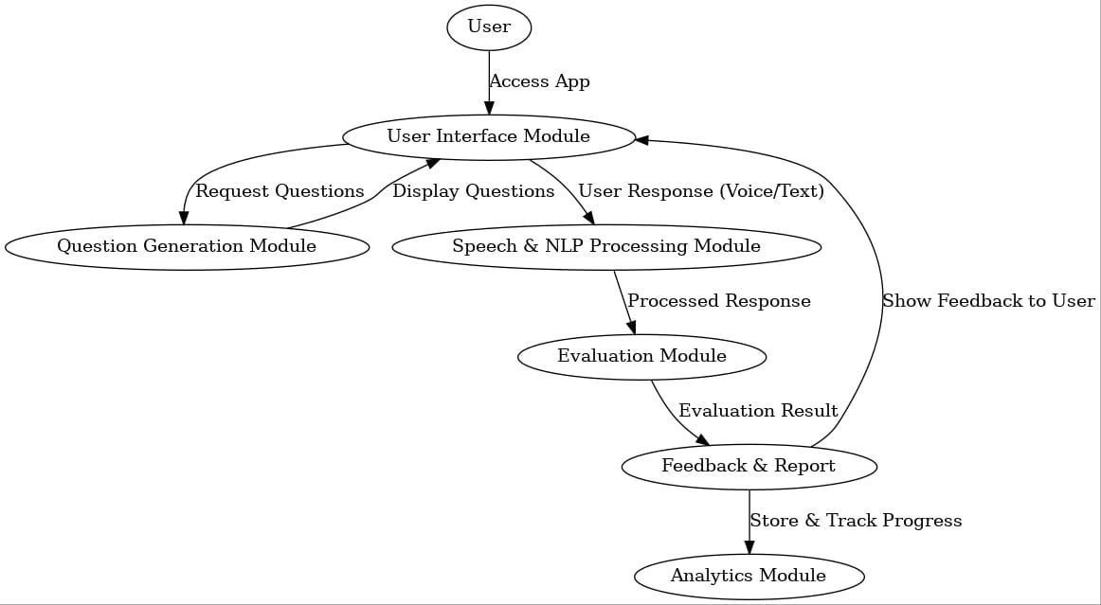

Deployment Diagram

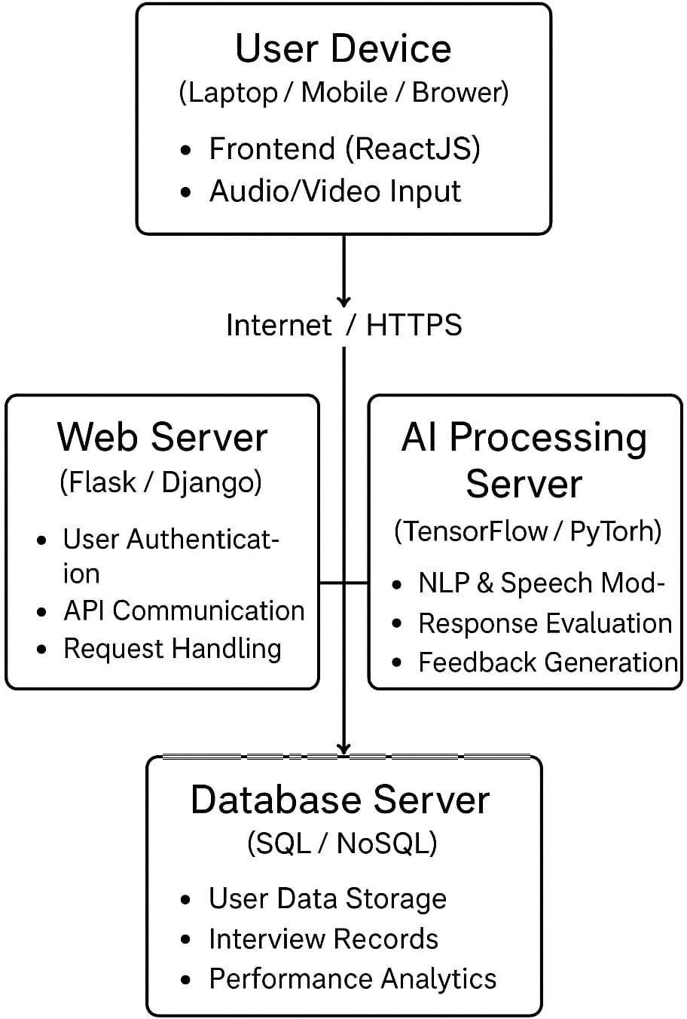

  - Data Design

A complete overview of the android could be seen and understood by the chart given

    - Use Case Diagram

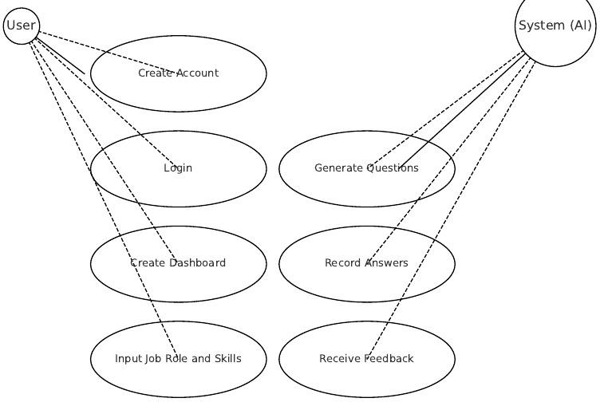

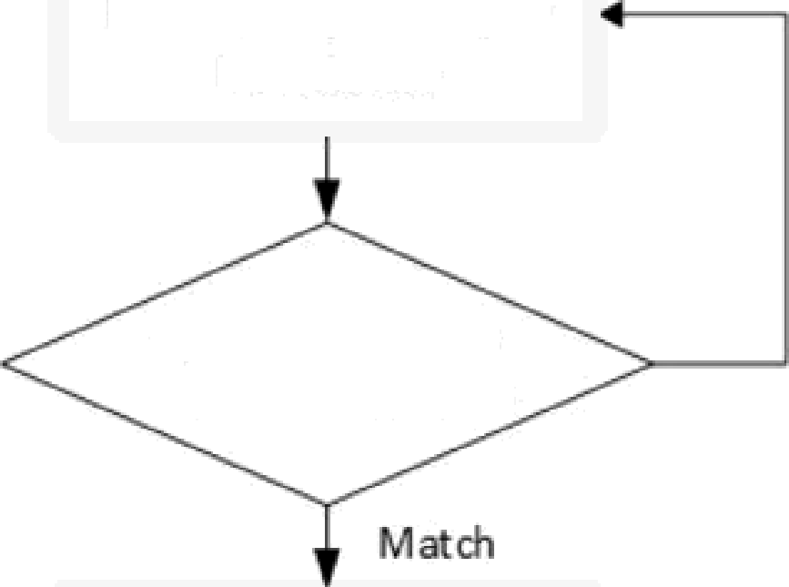
Procedural Design :

Interview Preparation

System crosscheck
interviewee identity

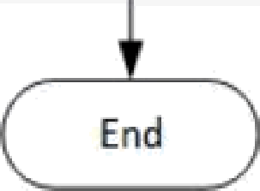
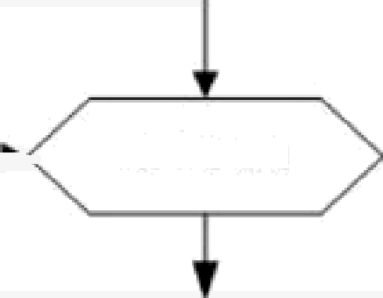
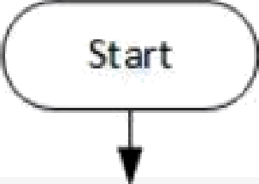
    - Logic Diagram
For i=1to N
Does not m atcn
Generate Main Question (or Com petency-i
Rapport & Closing Statement
System d eterm ine appropriate comp etency level (NLP / ML Process)
f
System Record Text Verbal Anns ers
Generate Sub Question Competency-i:
Situ ations, Tasks, Action s, Roles

Opening
1[
Introduction interviewer Bat & Clarify Ident’ity of Int erviewee

Algorithm Design
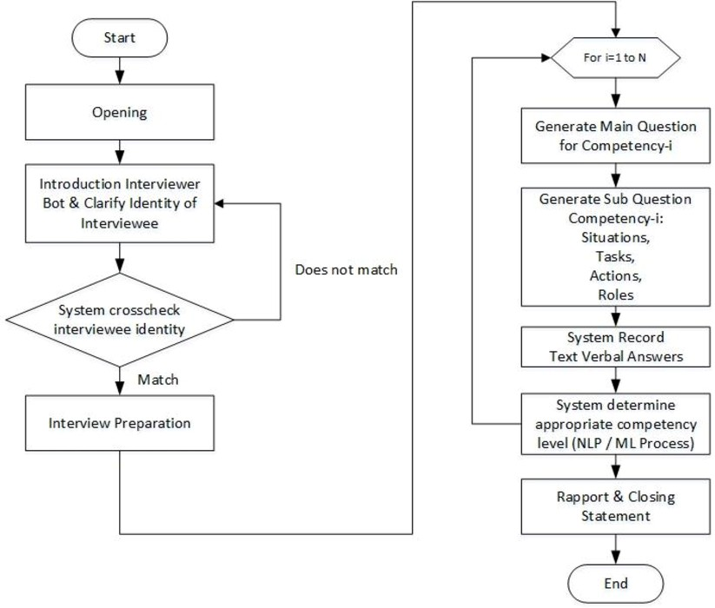

User Interface Design



Gantt Chart
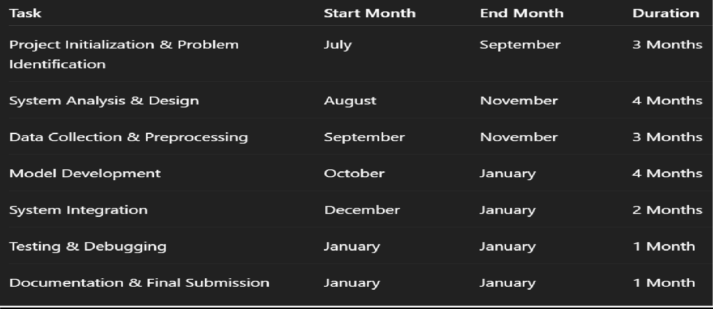

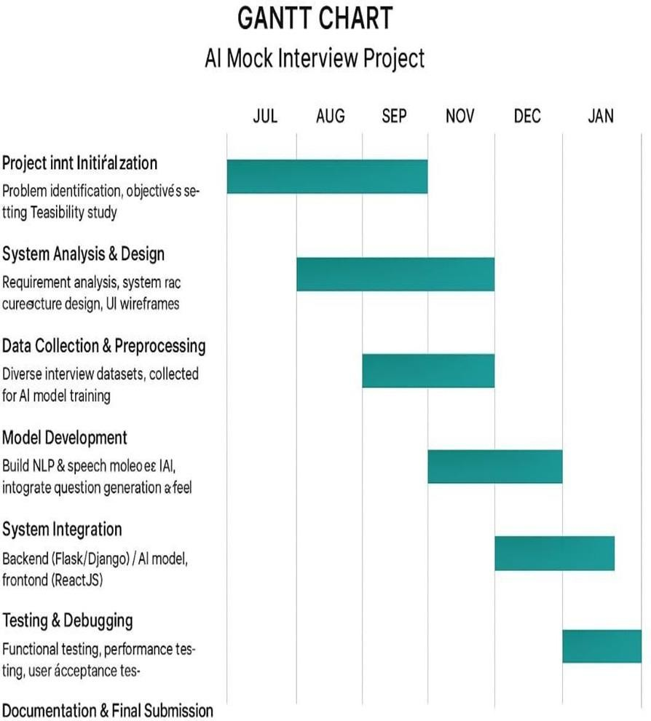

CHAPTER 4:

IMPLEMENTATION

Implementation in the AI Mock Interview System refers to the process of developing and integrating the frontend, backend, artificial intelligence services, and database to create a fully functional interview preparation platform.

It involves designing the user interface, developing backend APIs, integrating a pre-trained AI model for question generation and answer evaluation, managing user authentication, and storing interview data in the database. The implementation ensures smooth interaction between the user, the web application, and the AI services to simulate real interview scenarios.

1 Implementation Approaches
The AI Mock Interview System is implemented using a client–server architecture. The system is divided into frontend, backend, and external AI services to ensure modularity, scalability, and ease of maintenance.

The application follows a RESTful API-based implementation approach, where the frontend communicates with the backend through HTTP requests. The backend processes requests related to authentication, interview management, AI interaction, and database operations.

An incremental development approach is adopted. Core functionalities such as user authentication, interview flow, AI-based question generation, answer evaluation, and result storage are implemented and tested in stages. This approach helps in reducing errors and improving overall system stability.

Data Handling and Preprocessing
The AI Mock Interview System does not rely on a traditional static dataset. Instead, it processes real-time user input data and AI-generated content.
User inputs such as interview answers are validated to ensure they are non-empty and properly formatted before processing. The selected interview role, domain, and round are standardized to maintain consistency during AI prompt generation.

The responses received from the AI service are preprocessed to extract interview questions, scores, and feedback in a structured format. Error-handling mechanisms are implemented to manage improperly formatted AI outputs and ensure smooth execution of the interview process.

AI Integration Using OpenAI API
Instead of developing and training a custom machine learning model, the system integrates a pre-trained Large Language Model (LLM) using the OpenAI API.
The AI model is used for two main purposes:
    - Dynamic interview question generation based on role, domain, and interview round.
    - Answer evaluation and feedback generation, including scoring, strengths, and improvement suggestions.

Prompt engineering techniques are used to control the format and relevance of AI responses. This approach eliminates the need for large training datasets and significantly reduces development complexity while maintaining high accuracy and natural language understanding.

Backend Development Using Node.js and Express
The backend of the AI Mock Interview System is developed using Node.js with the Express framework. Express is used to create RESTful APIs that handle user registration, login authentication, interview session management, AI interactions, and database communication.

The backend acts as an intermediary between the frontend interface, the OpenAI API, and the Supabase database.
Secure password handling and structured API responses are implemented to ensure data integrity and system reliability.

Frontend Development Using HTML, CSS, and JavaScript

The frontend of the AI Mock Interview System is developed using HTML, CSS, and JavaScript to provide an interactive and user-friendly interview environment. The frontend acts as the primary interface through which users interact with the system.
HTML is used to structure the web pages such as login, registration, dashboard, interview, and analytics pages. CSS is applied to enhance the visual appearance of the application by designing responsive layouts, color themes, buttons, and chat-based interview components. JavaScript is used to handle dynamic behaviors, user interactions, and real-time communication with the backend APIs.
The interview interface is implemented in a chat-based format, where AI-generated questions are displayed and user responses are captured through text input. JavaScript fetch requests are used to communicate with backend services for question generation, answer evaluation, and session management. Real-time updates such as timers, progress indicators, and feedback display are also handled on the frontend.
User authentication status is maintained using browser storage to ensure secure access to protected pages. The frontend also provides a dashboard for users to view interview history, performance scores, and analytics in a structured manner.

Overall, the frontend implementation focuses on usability, responsiveness, and seamless integration with backend and AI services to deliver an effective mock interview experience.
Dashboard Design and Implementation Code :

<!DOCTYPE html>
<html lang="en">
<head>
<meta charset="UTF-8">
<title>AI Mock Interview Dashboard</title>
<meta name="viewport" content="width=device-width, initial-scale=1.0">

<link href="https://fonts.googleapis.com/css2?family=Inter:wght@400;500;600;700&display=swap" rel="stylesheet">

<link href="https://unpkg.com/boxicons@2.1.4/css/boxicons.min.css" rel="stylesheet">

<style>
*{
margin:0; padding:0;
box-sizing:border-box;
font-family:'Inter',sans-serif;
}

body{ background:#f6f7fb; display:flex;
}

/* SIDEBAR */
.sidebar{ width:250px; background:#ffffff; height:100vh; padding:25px;
border-right:1px solid #eee;
}

.logo{ display:flex;
align-items:center; gap:10px;
font-size:22px; font-weight:700;
margin-bottom:40px;
}

.logo span{ background:#6366f1; color:#fff; width:36px; height:36px; display:flex;
align-items:center; justify-content:center; border-radius:8px;
}

.menu a{ display:flex;
align-items:center; gap:12px; padding:12px;

margin-bottom:8px; border-radius:10px; color:#444;
text-decoration:none; font-weight:500;
}
.menu a i{
font-size:20px;
}

.menu a.active,
.menu a:hover{ background:#eef2ff; color:#4f46e5;
}

.submenu{
margin-left:35px;
}

.submenu a{ font-size:14px; padding:8px;
}

/* MAIN */
.main{ flex:1;
padding:30px;
}

/* TOP BAR */
.topbar{ display:flex;
justify-content:space-between; align-items:center;
margin-bottom:25px;
}

.search{ background:#fff; padding:12px 18px; border-radius:12px; width:320px; display:flex;
align-items:center; gap:10px;
box-shadow:0 4px 10px rgba(0,0,0,.05);

}

.search input{ border:none; outline:none; width:100%;
}

.profile{ display:flex;
align-items:center; gap:12px;
}

.profile img{ width:38px; height:38px; border-radius:50%;
}

/* CARDS */
.cards{ display:grid;
grid-template-columns:repeat(auto-fit,minmax(240px,1fr)); gap:20px;
margin-bottom:30px;
}

.card{ background:#fff; padding:22px; border-radius:18px;
box-shadow:0 10px 20px rgba(0,0,0,.06);
}

.card h4{
font-size:14px; color:#6b7280; margin-bottom:10px;
}

.card p{
font-size:28px; font-weight:700;
}

.card small{ color:#10b981;
}

/* TABLE */
.section{ background:#fff; padding:25px; border-radius:18px;
box-shadow:0 10px 20px rgba(0,0,0,.06);
}

.section h3{
margin-bottom:20px;
}

table{ width:100%;
border-collapse:collapse;
}

th,td{ padding:14px; text-align:left; font-size:14px;
}

thead{ background:#f3f4f6;
}

tbody tr:hover{ background:#f9fafb;
}

.status{ padding:5px 12px;
border-radius:20px; font-size:12px;
}

.review{background:#fff7ed;color:#ea580c}
.complete{background:#ecfdf5;color:#059669}
.incomplete{background:#fef2f2;color:#dc2626}

/* RESPONSIVE */
@media(max-width:900px){
.sidebar{display:none;}
}
</style>
</head>

<body>

<!-- SIDEBAR -->
<div class="sidebar">

<div class="logo">
<span>AI</span> ACE YOUR INTERVIEW
</div>

<div class="menu">
<a href="#" class="active"><i class='bx bxs-dashboard'></i>Dashboard</a>
<a href="resume (1).html"><i class='bx bxs-file'></i>Resume</a>
<a href="select.html"><i class='bx bxs-envelope'></i>Start Interview</a>
<a href="Technical.html"><i class='bx bxs-envelope'></i>Technical Round</a>
<a href="Hr.html"><i class='bx bxs-envelope'></i>HR Round</a>
<a href="analytics.html"><i class='bx bxs-layout'></i>Performance Graph</a>
<a href="interview-library.html"><i class='bx bxs-microphone'></i>Interview Library</a>
<a href="help centre.html"><i class='bx bx-help-circle'></i>Help Center</a>
<a href="setting.html"><i class='bx bx-cog'></i>Settings</a>
<a href="index (1).html"><i class='bx bx-log-out'></i>Log out</a>
</div>

</div>

<!-- MAIN -->
<div class="main">

<!-- TOP BAR -->
<div class="topbar">
<div class="search">
<i class='bx bx-search'></i>
<input type="text" placeholder="Search">
</div>

<div class="profile">
<span>Hello, Student</span>
<img src="https://cdn-icons-png.flaticon.com/512/149/149071.png">
</div>
</div>

<!-- OVERVIEW -->
<div class="cards">

<div class="card">
<h4>Interview Practice</h4>
<p>12</p>
<small>▲ 10% from last week</small>
</div>

<div class="card">
<h4>Question Complete</h4>
<p>24</p>
<small>▲ 10% from last week</small>
</div>

<div class="card">
<h4>Interview Time</h4>
<p>00:24</p>
<small>hours</small>
</div>

</div>

<!-- HISTORY -->
<div class="section">
<h3>Interview History</h3>

<table>
<thead>
<tr>
<th>Rounds</th>
<th>Category</th>
<th>Results</th>
<th>Date</th>
</tr>
</thead>

<tbody>
<tr>
<td>Aptitude</td>
<td>Data Science</td>
<td><span class="status complete">View feedback</span></td>
<td>02 Sep 23</td>
</tr>

<tr>
<td>Technical</td>
<td>Skill</td>
<td><span class="status review">In review</span></td>
<td>15 Aug 23</td>
</tr>

<tr>
<td>Hr</td>
<td>Problem solving</td>
<td><span class="status review">In review</span></td>
<td>01 Sep 23</td>
</tr>

<tr>
<td>Technical</td>
<td>Decision making</td>
<td><span class="status incomplete">Incomplete</span></td>
<td>01 Aug 23</td>
</tr>
</tbody>
</table>

</div>

</div>

</body>
</html>

CHAPTER 5:

RESULT

User Documentation :

Home Page
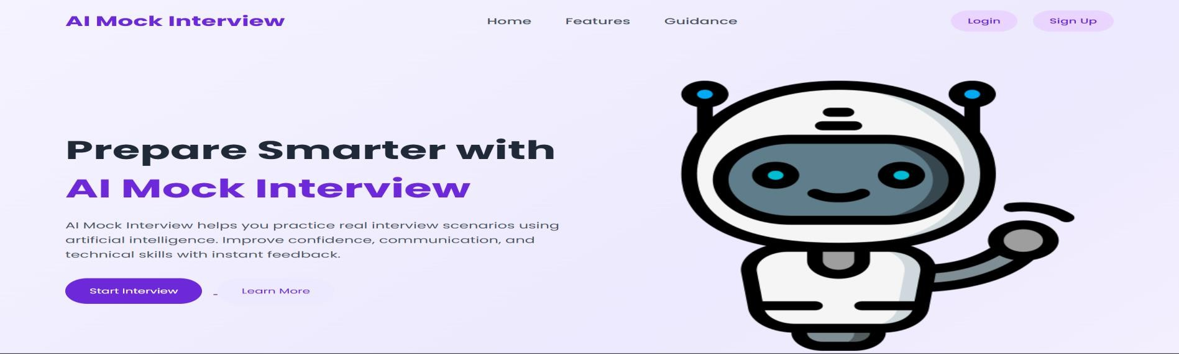

Login Page Result
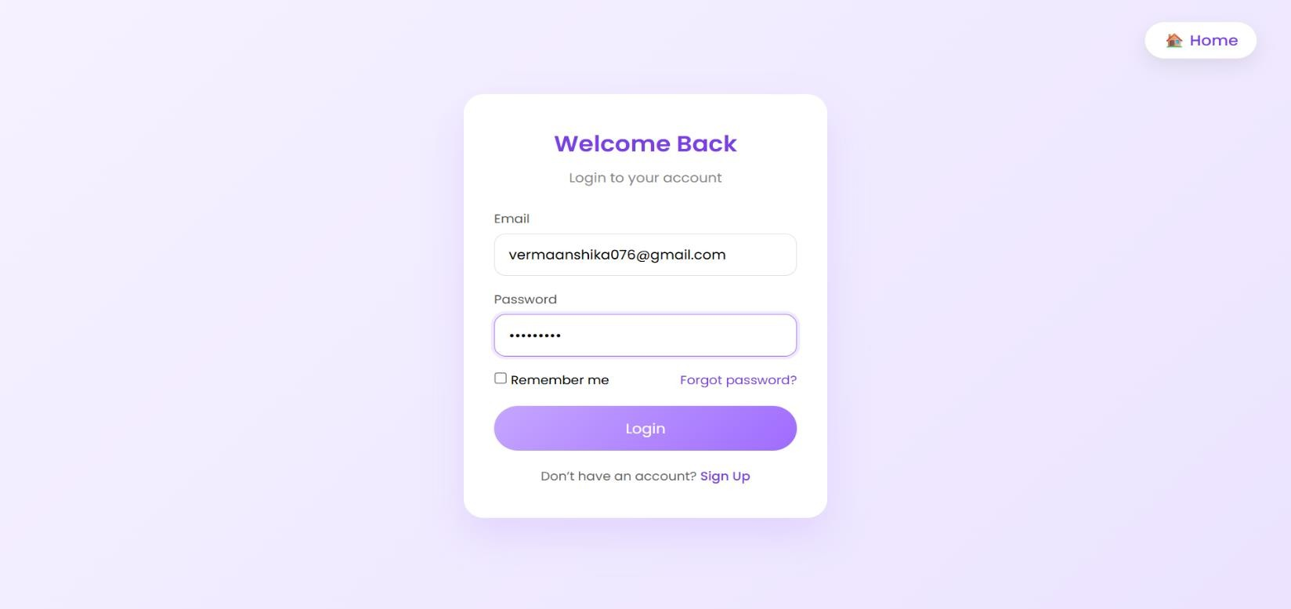

Dashboard Page Result
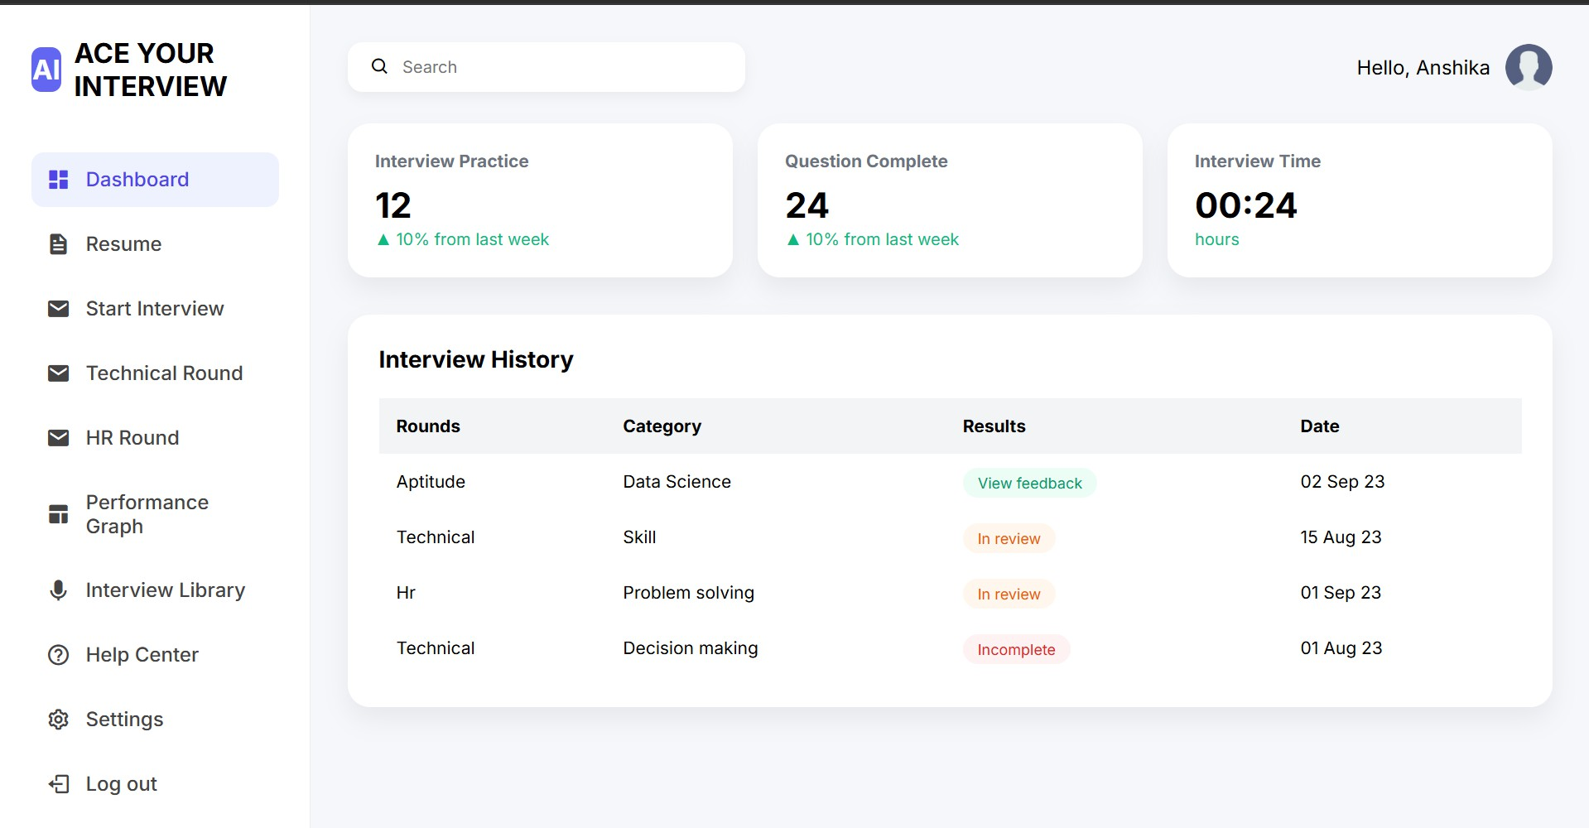

Interview Question & Evaluation Result
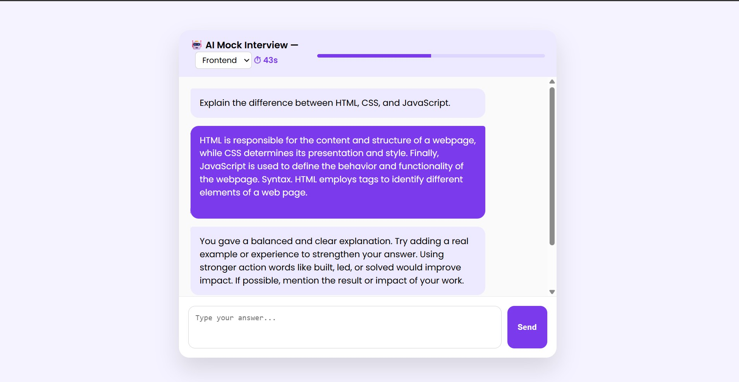

Performance Analytics Result
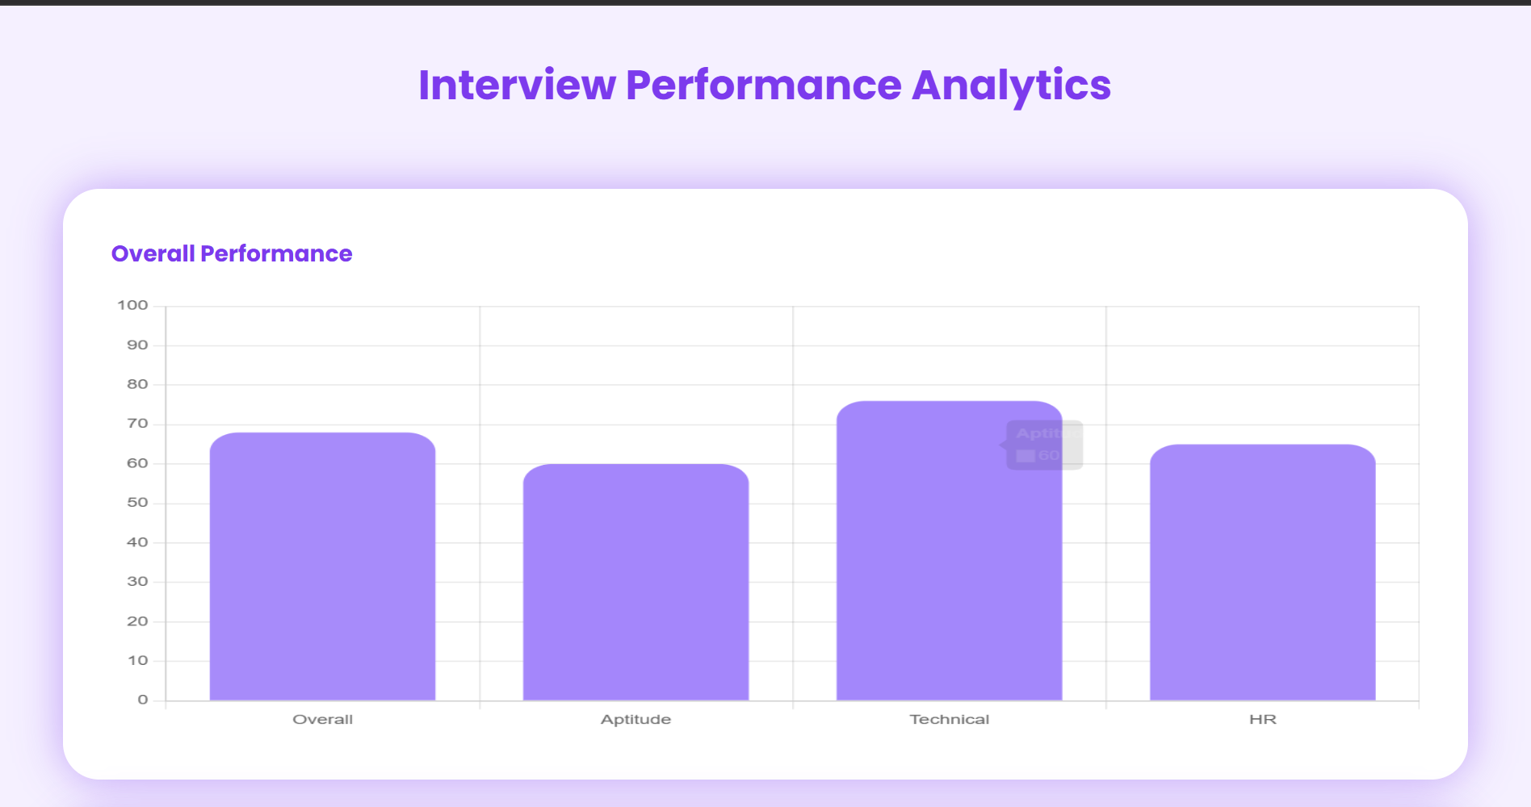

CHAPTER 6:

CONCLUSION AND FUTURE SCOPE

Conclusion
The AI Mock Interview System was successfully designed and implemented to provide an interactive and intelligent platform for interview preparation. The system integrates modern web technologies with artificial intelligence to simulate real-world interview scenarios for users across different domains and roles.

By leveraging a pre-trained Large Language Model through the OpenAI API, the application dynamically generates interview questions and evaluates user responses with constructive feedback. The use of a chat-based interface enhances user engagement and provides a realistic interview experience. The backend developed using Node.js and Express ensures secure authentication, efficient data handling, and seamless communication between the frontend and external services.

The system successfully achieves its objectives of automating interview practice, reducing dependency on human interviewers, and offering personalized feedback. This project demonstrates how AI-driven applications can significantly improve learning and self-assessment in professional skill development.

Limitations of the System
Despite its effectiveness, the system has certain limitations. The quality of interview questions and evaluations depends on the availability and performance of external AI services. Internet connectivity is required for real-time AI interactions, which may affect accessibility in low-connectivity environments.

Additionally, while the system provides qualitative feedback, it does not currently support voice-based interviews or real-time emotion analysis. The evaluation process is text-based and may not fully capture communication skills such as tone, confidence, or body language.

Future Scope
The AI Mock Interview System can be further enhanced with several advanced features. In the future, voice-based interviews can be integrated using speech recognition to simulate real interview conditions. Resume-based question generation can be introduced to provide highly personalized interview sessions.
The system can also incorporate video interviews with facial expression and sentiment analysis to assess confidence and communication skills. Advanced analytics and performance tracking dashboards can be added to visualize user progress over time.

Integration of additional AI models and multilingual support would allow the system to cater to a wider audience. With these enhancements, the application has the potential to evolve into a comprehensive AI-powered career preparation platform.

CHAPTER 7:

REFERENCE & BIBLOGRAPHY

RE FERENCES
    - OpenAI, OpenAI API Documentation, Available at: https://platform.openai.com/docs
    - Node.js, Node.js Official Documentation, Available at: https://nodejs.org/en/docs/
    - Express.js, Express Framework Documentation, Available at: https://expressjs.com/
    - Superbase, Superbase Documentation, Available at: https://supabase.com/docs
    - Mozilla Developer Network, HTML, CSS, and JavaScript Documentation, Available at: https://developer.mozilla.org/
    - Artificial Intelligence: A Modern Approach, Stuart Russell and Peter Norvig, Pearson Education, 4th Edition, 2021.
    - Web Development with Node and Express, Ethan Brown, O’Reilly Media, 2019.

BIBLIOGRAPHY
- Ian Sommerville, Software Engineering, Pearson Education, 10th Edition, 2016.
- PostgreSQL, PostgreSQL Documentation, Available at: https://www.postgresql.org/docs/
- GitHub, GitHub Documentation, Available at: https://docs.github.com/
- Chart.js, Chart.js Documentation, Available at: https://www.chartjs.org/docs/
- Deep Learning, Ian Goodfellow, Yoshua Bengio, and Aaron Courville, MIT Press, 2016.

